**Project Title : Employee Rewards And Recognition**

**Business Requirements:**

* **Functional Requriements**
  + **Employee Data Object Management**
    - Creation of custom Object to store employee records
    - It includes Fields like Employee Name, ID, Attendance, Performance etc.
  + **Top Performer Identification**
    - The System has to Identify the top 4-5 employees who are at the top based on the criteria.
  + **Automated Reward Evaluation**
    - Rewards Should be awarded to the employee based on their performance automatically for every 6 months.
  + **Email Notification**
    - After the evaluation of the reward the email has to be sent to the selected top performers which contain reward type.
* **Non – Functional Requirements**
  + **Security** 
    - Only authorized admins should be able to modify and access the reward assignment.
    - Use Profiles to control access.
  + **Scalability**
    - It must be capable of handling a growing number of employee records.

**Step 1: Creating App**

Switch to Salesforce Classic

Setup > Build > Create > Apps > Quick Start

Create Employee Recognition Tracker app

Add the Following tabs to Selected Tabs

* Home
* Employees
* Dashboards
* Reports

Default landing tab : Dashboard

Save

Switch to Lightning

Setup > App Manager > Apps > Employee Recognition Tracker > Edit

Check Show in Lightning

Save

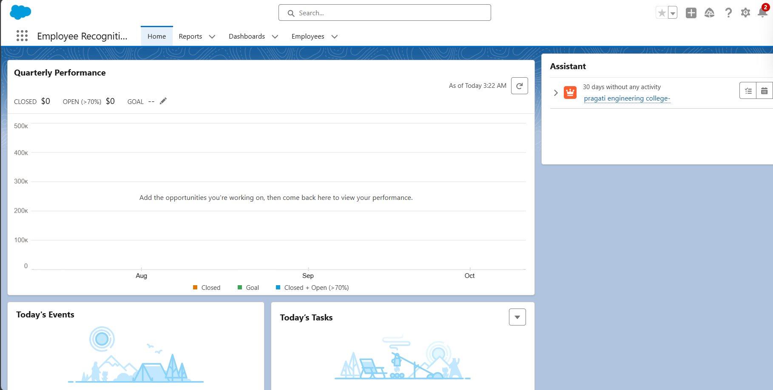

**Step 2 : Profiles Creation**

**Create profile**

Setup > Quick Find > Profiles

Create New Profile

Existing Profile : Standard user

Profile Name : HR Manager

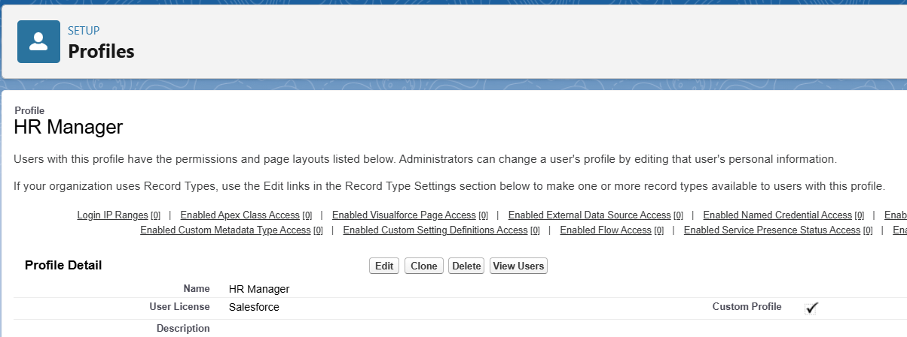

**Create user**

Create new user and assign Profile HR Manager

**Step 3 : Create Object and Add fields**

Setup → Object Manager → Create → Custom Object  
- Fill in Label & Plural Label  
- Enable all optional features, search status, and object creation options  
- Click Save

Setup → Object Manager → Create → Custom Object → Fill Label & Plural Label → Click all Optional Features, Search Status & Object Creation Options and then Save

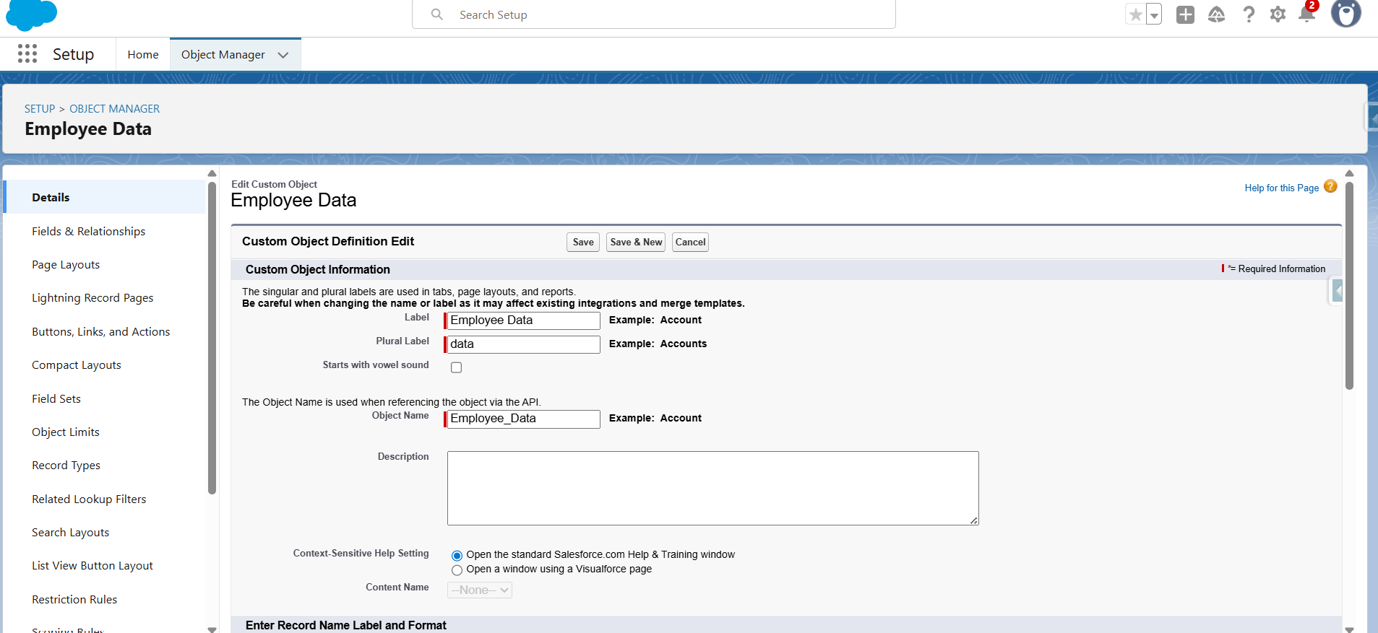

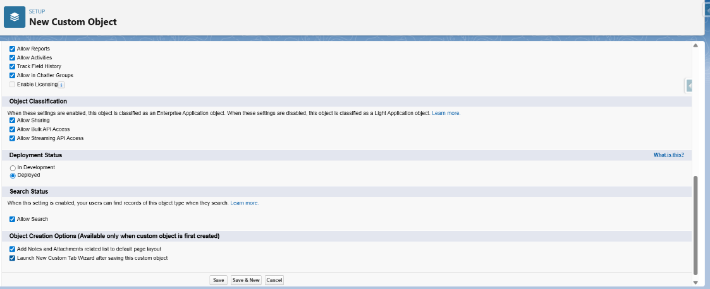

Fields and relationships----->New----->datatype related to field required---->next

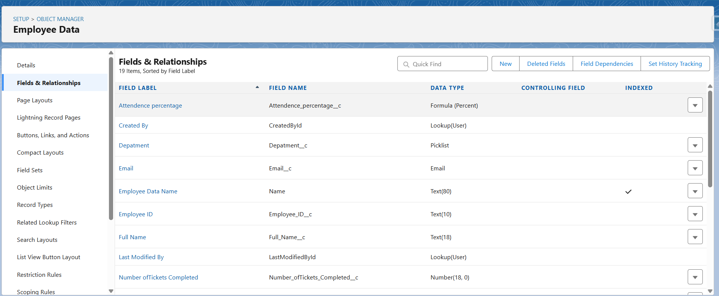

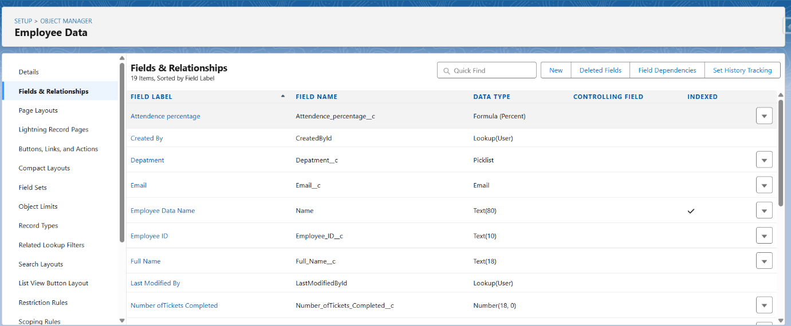

**Step 3 : Flows**

**Creating Schedule Trigger Flow**

Setup 🡪 quick find 🡪 flows 🡪 new flow 🡪 schedule trigger flow

Start Date : Jan

Time : 12:00 AM

Frequency : Once

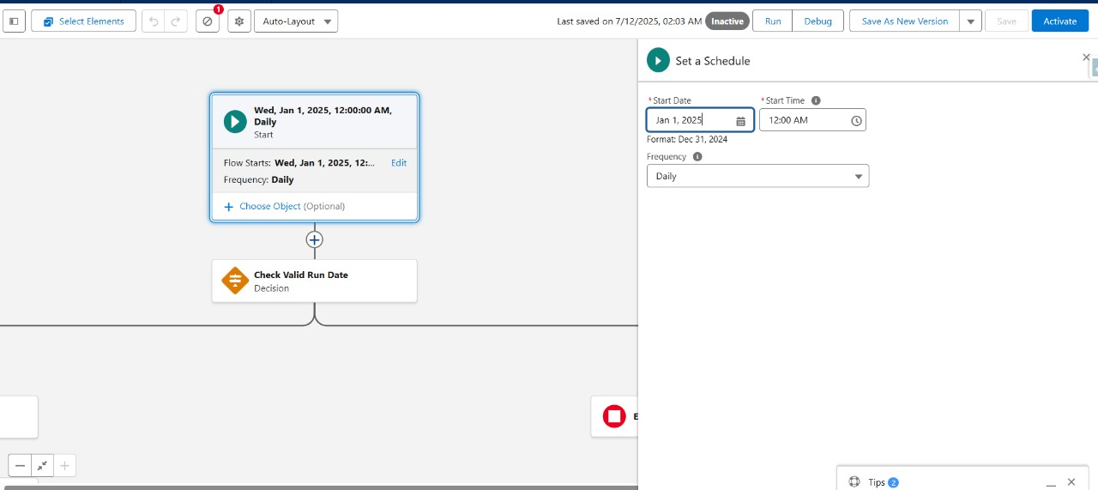

**Create new resource**

Resource Type : Formula

API_Name : Is_Jan

Data Type : Boolean

Formula : Month(TODAY()) = 1 && DAY(TODAY()) = 1

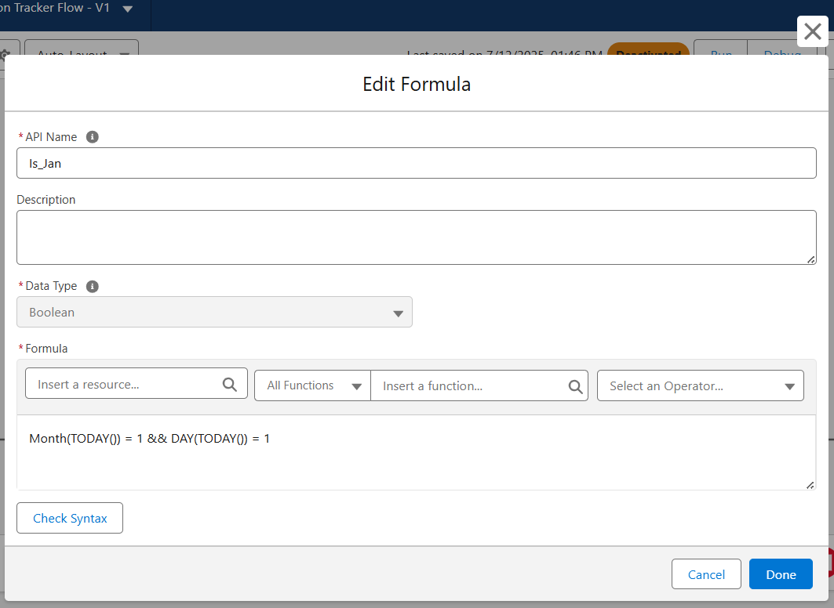

Same for Is_July And for Is_Today In Place of Formula Enter TRUE

Click on Plus After Start and Select Decision

**Check Valid Run Date**

Label : Check Valid Run Date

API Name : Auto Filled

Out Come Details :

Label : Is_Jan or July

Condition Requirements to Execute Outcome : Custom Condition Logic Is Met

Condition Logic : 1 OR 2 OR 3

Resource : Is_Jan

Operator : Equals

Value : True

Same for is_july and IS_today

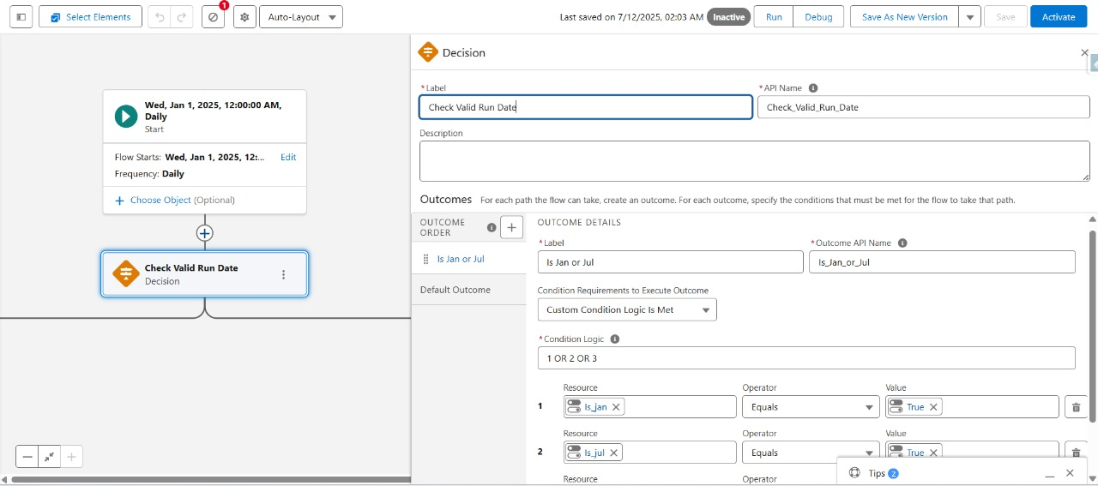

Click on plus afer Is_Jan or July

**Get Qualified Employees**

Label : Get Qualified Employees

Object : Employee Data

Filter Conditions : All Conditions Are Met

* Field : Attendance Percentage

Operator : Greater Than

Value : 90

* Field : Performance Based Score

Operator : Greater Than

Value : 0.9

* Field : Task Completion Percentage

Operator : Greater Than

Value : 90

Sorted Order: Descending

How Many Records to Store: All, Records Up to a Specified Limit

Max Number : 4

How to Store Record Data : Automatically Store All Fields

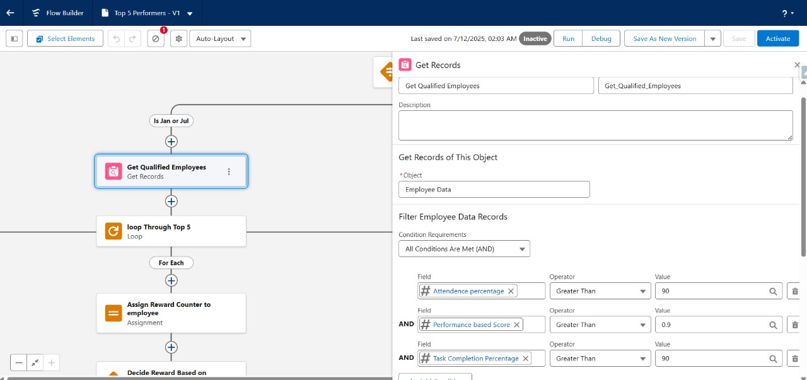

Click on Plus Below Get Qualified Employee and Select Loop

**Loop through top 5**

Label : Loop Through Top 5

Collection Variable : Data from qualified Employee

Direction : First item to Last item

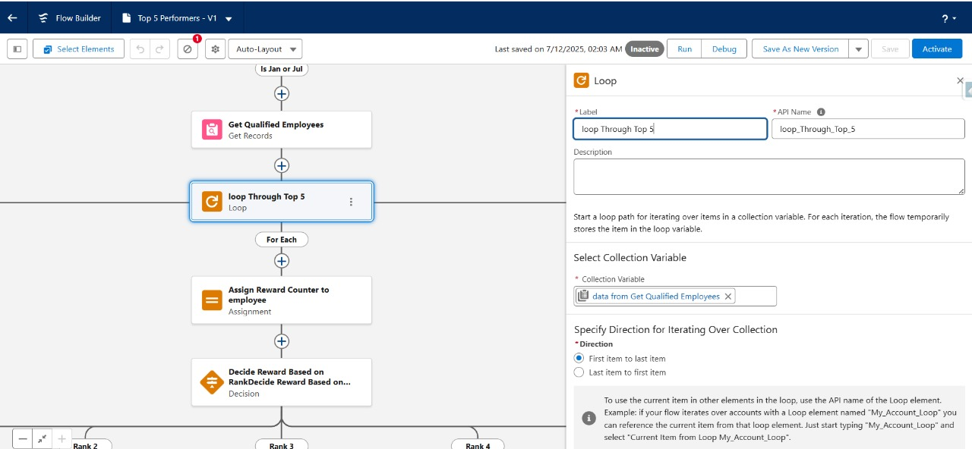

Click on plus below the for each and Click Assignment

**Assign Reward Counter To Employee**

Label : Assign Reward Counter to Employee

* Variable : Loop through top 5 > Top 5 Performer

Operator : Equals

Value : True

* Variable : Loop Through Top 5 > Rank

Operator : Equals

Value : Reward Counter

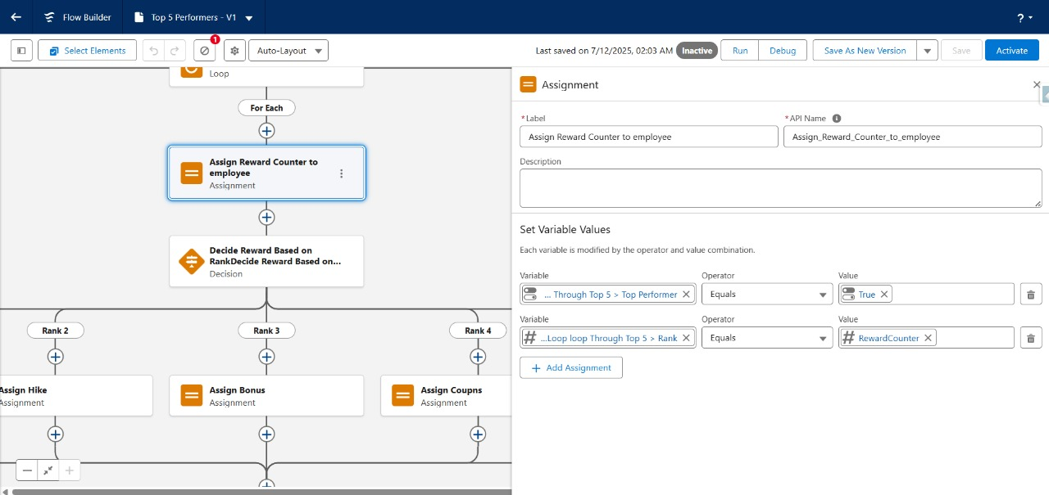

Click plus after assign reward counter to employee and click on decision

**Decide reward based on rank**

Label : Decide Reward Based on Rank

Out come Details :

Label : Rank 1

Resource : Reward Counter

Operator : equals

Value : 1

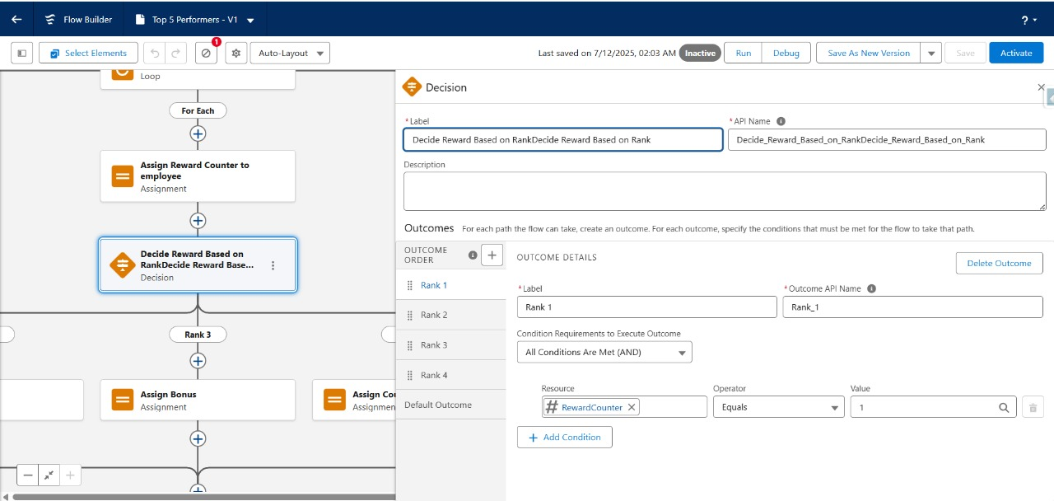

Do same for Rank 2, 3, 4 and click on plus symbol after that and click assignment

Label : Vacation

Set Variable Values >

Variable : Loop Through Top 5 > Rank

Operator : Equals

Value : Vacation

Do the same and assign rewards for each path of Ranks 1, 2, 3, 4

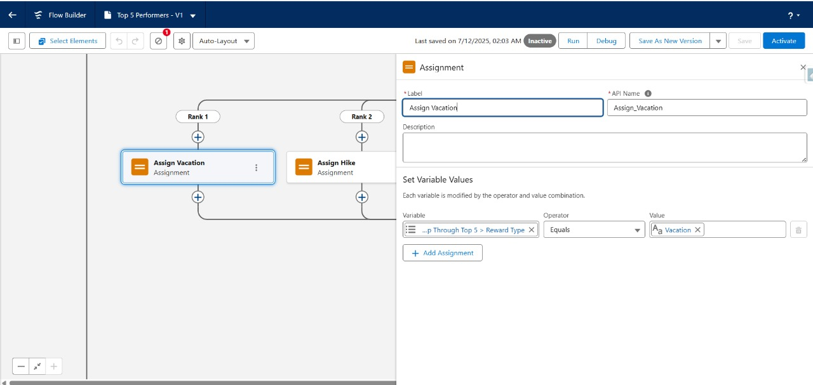

Rank 1 : vacation

Rank 2 : Hike

Rank 3 : Bonus

Rank 4 : Coupons

**Increment Reward Counter**

Label : Increment Reward Counter

Variable : Reward Counter

Operator : And

Value : 1

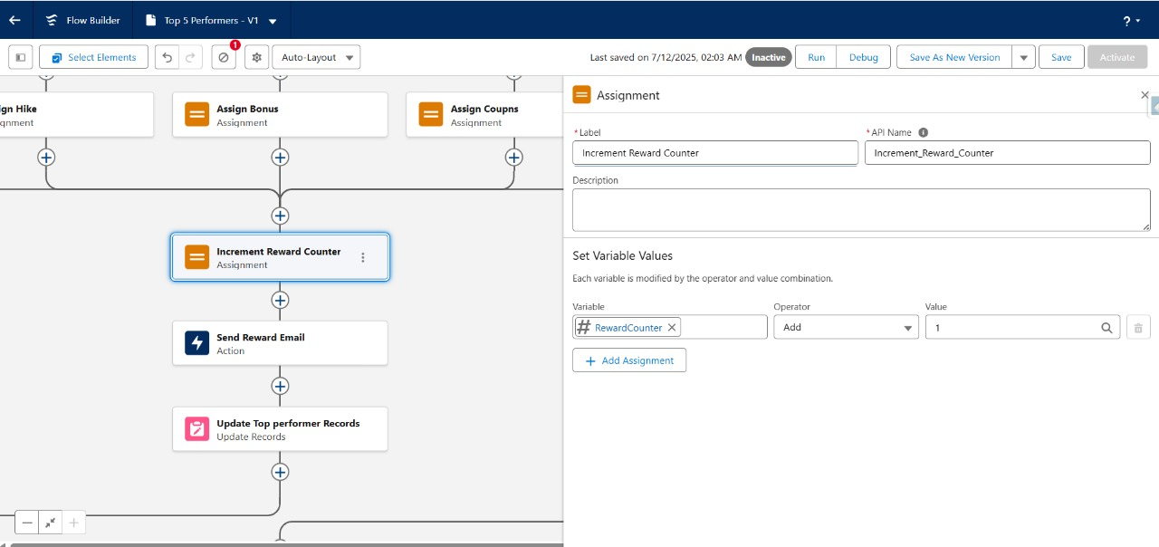

Click plus after increment reward counter and select action

**Send Reward Email**

Label : Send reward Email

Recipient Address list:

CC Recipient Address List:

Sender Type: CurrentUser

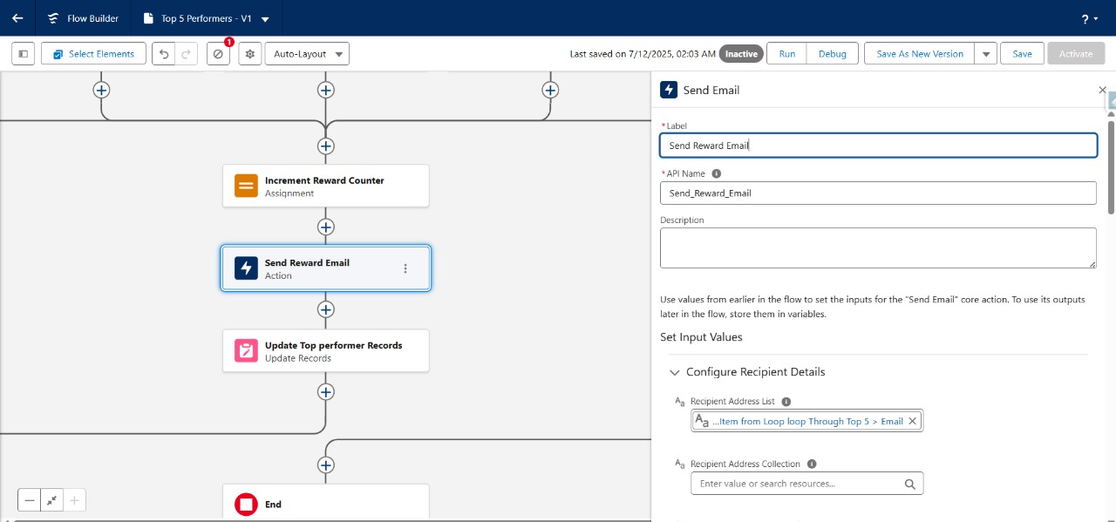

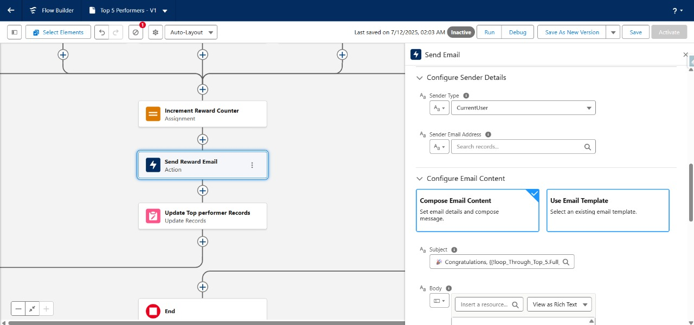

**Step 4 : Reports & Dashboards**

**Creating Reports**

For the sample data we have used a .csv file having the fields required.

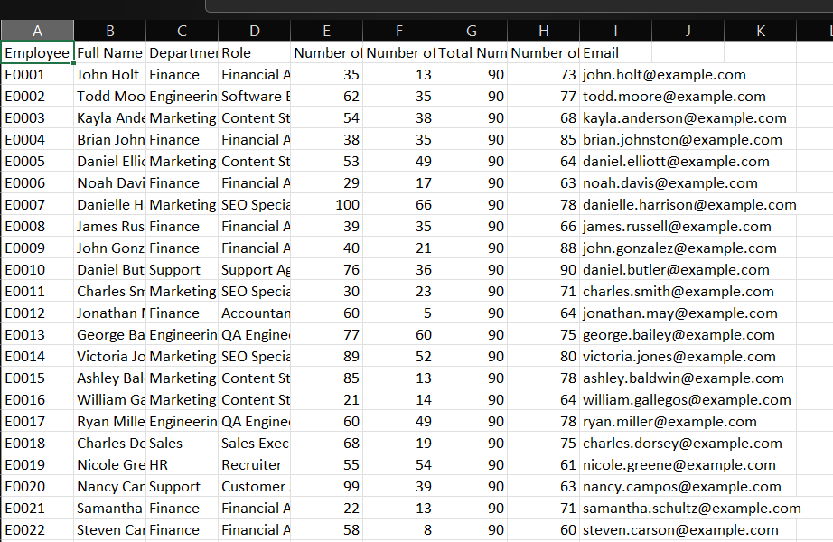

Import the data using Salesforce Inspector

Object :Employee Data

Data : Paste all the fields into the area

Map all the fields

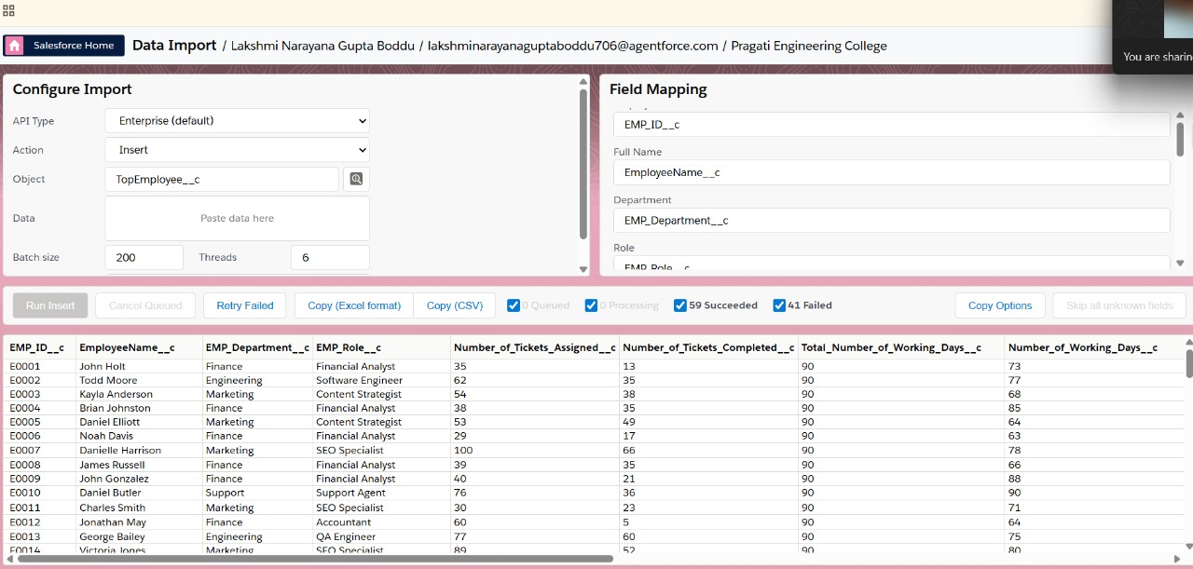

Run Insert

**Reports Creation for dashboards**

App Launcher > Reports

Create New Folder

Label : Employee Recognition Reports

Click New Report

Select Employee Objects

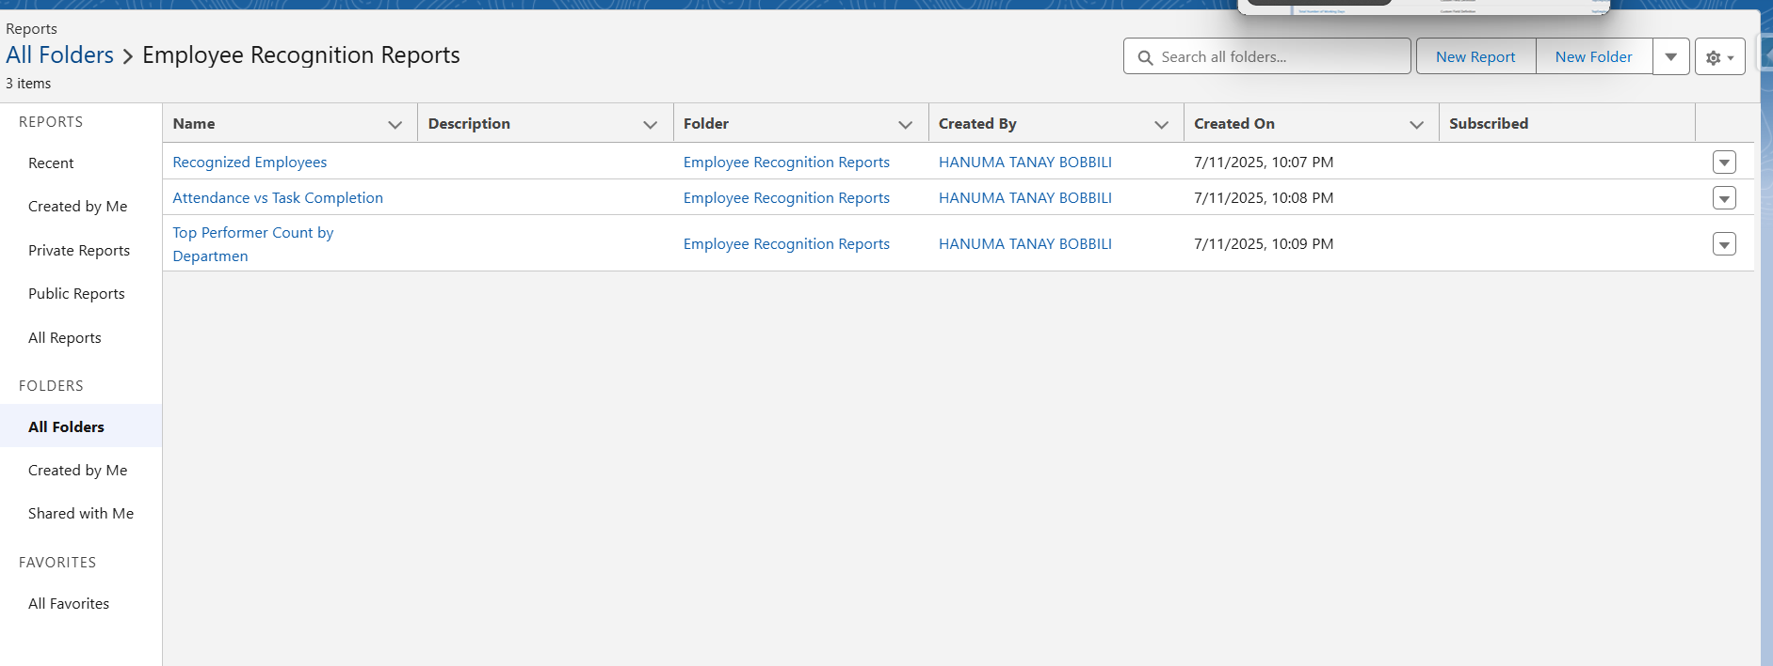

Create These 3 Reports

**Recognized Employees**

Columns : Employeename, Department, Performance Score, Reward Type, Rank

Filters :

* Attendance Percentage > 90
* Performance Score > 0.9
* Tasks Completion percentage > 90
* Top Performer = true

Save

* In the same way Create the other 2 reports
* Top Performer Count by Department
* Attendance Vs Task Completion

**Dashboard Creation**

New Folder: Employee Recognition Dashboard

Add 3 Reports

Adjust the positions

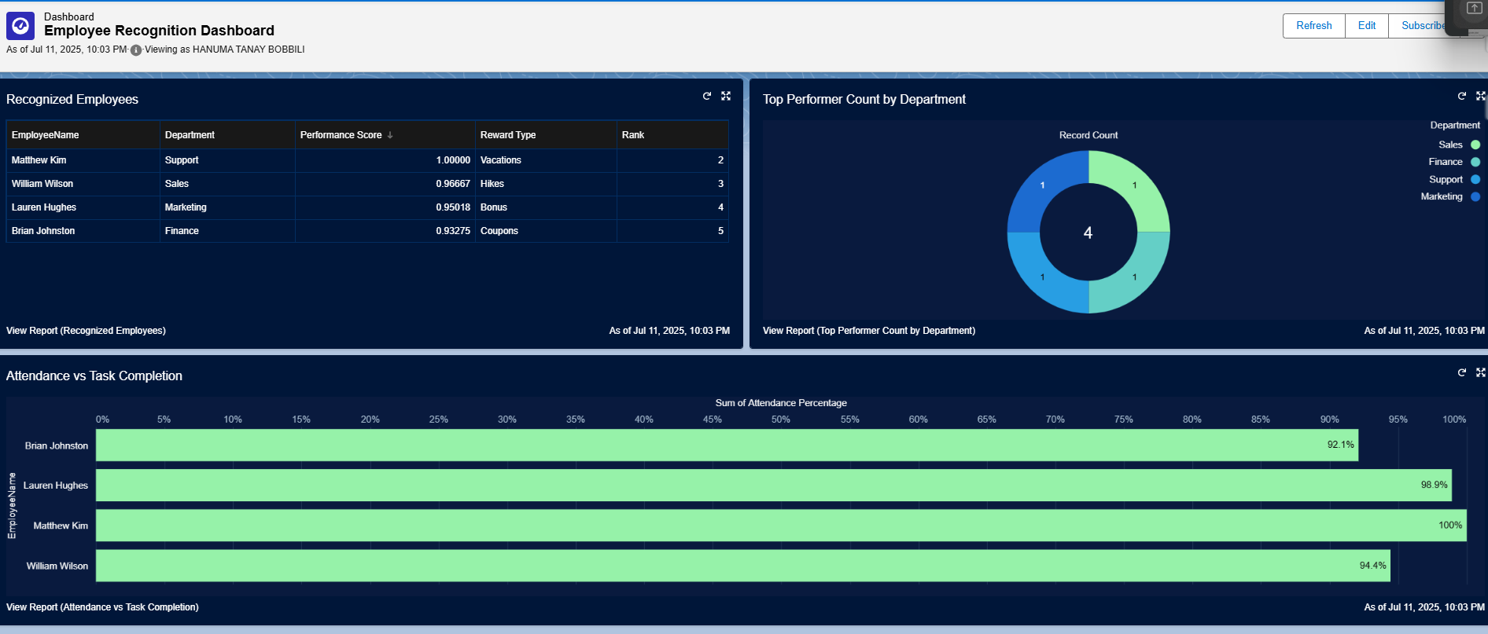

Click Save.

**Step 6: Dashboard Access Configuration**

**Configuring Dashboard Access**

Select Drodown aside Employee Recognition folder in Dashboards where Dashboard is Present

And click share

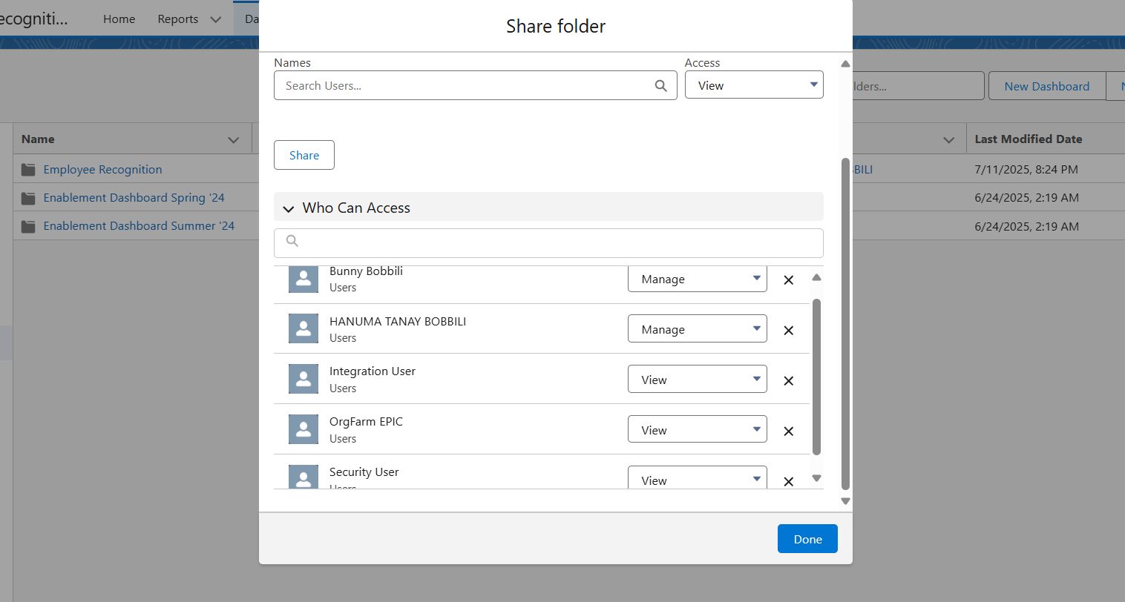

Select Users Under Share With

Under Names

Select each user and edit access and click share

User (System Administrator) - Manage Access

User (HR Manager) – Manage Access

Rest of Users – View Access

Done

**Tools Related**

This Project was fully implemented using Salesforce Admin Tools without any third party apps.

**Tool / Feature Purpose**

**Object Manager** Created Custom Objects and Fields

**Profiles** Controlled access using the custom profiles

**Flows(Process Automation)** Implemented to generate the reports and to send reward mails to the top

performers

**Reports & Dashboards** Visualized data like the top performers

**Testing Results:**

**Test Case ID Test Description Input/Setup Expected Result Actual Result Status**

TC_01 Custom Object Created emp All fields are Sucessfully Passed

& field Creation data with created and Created all

required fields visible in the fields

object

TC_02 Filter Qualified Records with Only eligible Correct list Passed

Employees Performance employees Returned

Fetched

TC_03 Email sent to Triggered Flow Email sent to All 4 emails Passed

Winners After Assignment to top 4 Received

**Test Environment**

* **Salesforce Org Type**: Developer Edition
* **Data Used**: 50 sample records, 5 high performers
* **Test Tools**: Flow Debug, Email Log, Object Record View